CSA1411-COMPILER DESIGN

LAB EXPERIMENTS

NAME:- R KALAI AMUDHAN

REG NO:- 192511292

EXPERIMENT – 13:
AIM:-
Write a C program to implement either Top Down parsing technique or Bottom Up Parsing technique to check whether the given input string is satisfying the grammar or not.
CODE:-
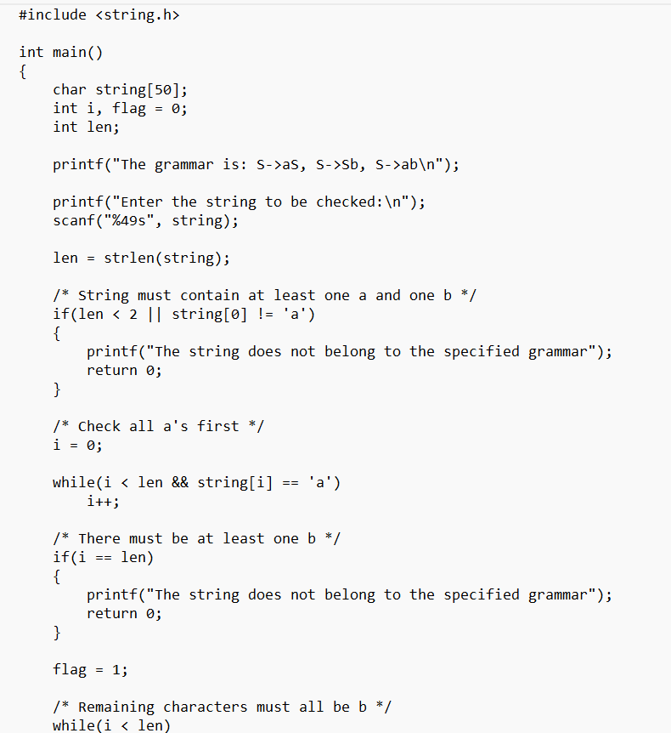
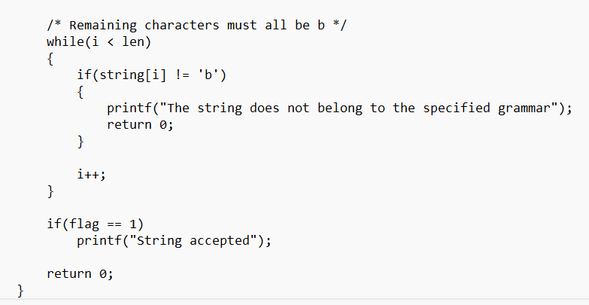
OUTPUT:-
